1. **What is the basic difference and similarity between a vector and a matrix?**

Ans--> Difference: A vector is **one-dimensional** (e.g. a list of numbers that can be in a row or column), while a matrix is **multi-dimensional** (e.g.a rectangular (mxn) array of numbers; which can be one or more rows, and one or more columns).

Difference: A vector is **one-dimensional** (e.g. a list of numbers that can be in a row or column), while a matrix is **multi-dimensional** (e.g.a rectangular (mxn) array of numbers; which can be one or more rows, and one or more columns).

1. **What is the basic difference and similarity between a data frame and a matrix?**

Ans-->Difference: In R, a matrix is a **homogeneous** collection of data sets which is arranged in a two-dimensional (mxn) rectangular organisation. On the other hand, a data frame is **heterogeneous** (i.e. it can contain multiple data types such as numeric, character, factor, in multiple columns). In a data frame, each column contains the values of a variable, and each row contains one set of values from each column.

Similarity: Both are data structures to organize data so that it can be used effectively, and both are **two-dimensional**.

1. **Create a vector using (15, TRUE, “World”). What happened to your result?**

Ans-->As a vector needs to be of the same data type, vector <- c(15, TRUE, “WORLD”) will result in an error due to error in inputs.

1. **John’s scores in the final semester for the three subjects are 95, 91, and 88. The subjects are Statistics, Linear Algebra, and Calculus. Using these create a vector and give names to all elements of the vector based on their subjects.**

Ans-->Assign vector, then use the **names()** **function.**

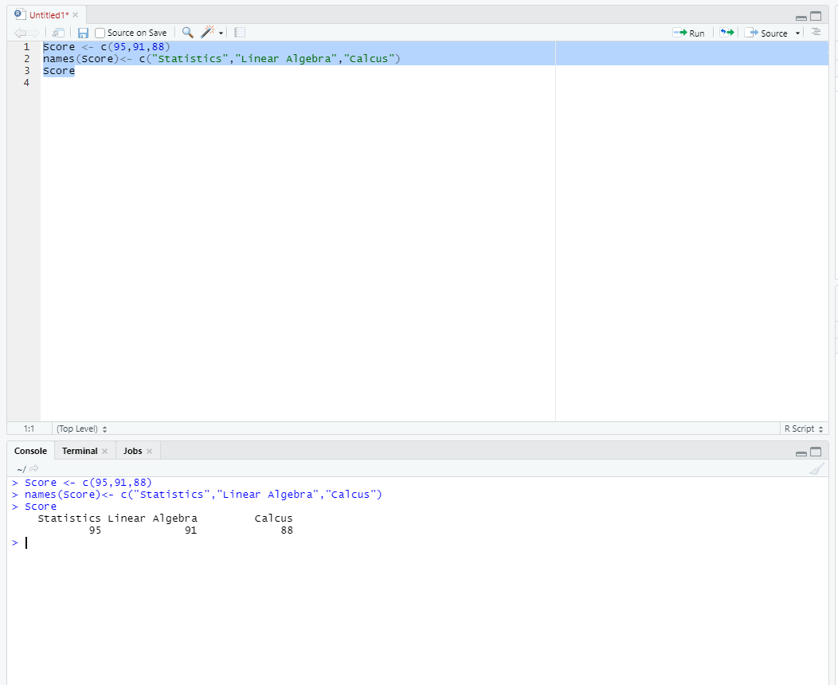

1. **Please check the types (character or numeric) of the vector you created.**

Ans--> class(score) = **numeric.**

1. **You have three students in your class (choose any name you want). You must create a matrix using their score in the above mentioned subjects (question 4) Student 1 (95, 91, and 88), Student 2(96, 94, and 97), Student 3(88, 98, and 85). Create a matrix and label column and row names.**

Ans>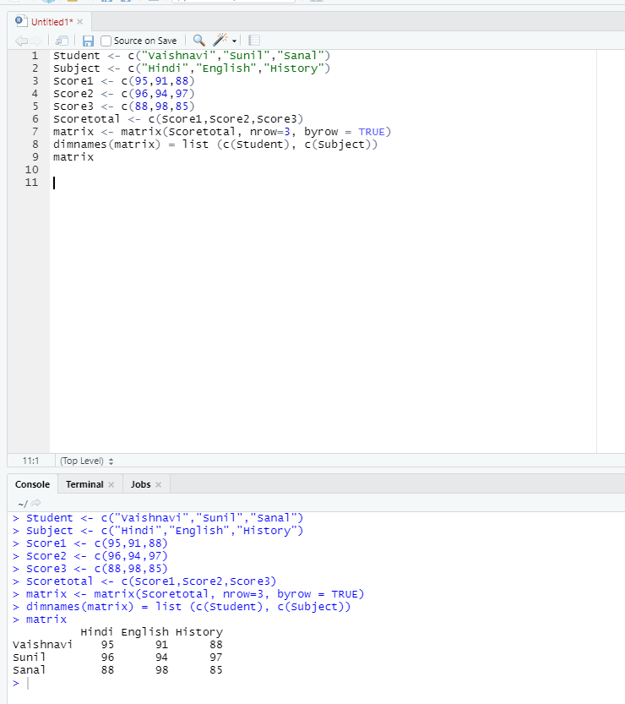

1. **Convert the created matrix into a data frame.**

Ans--> Use data.frame() function.

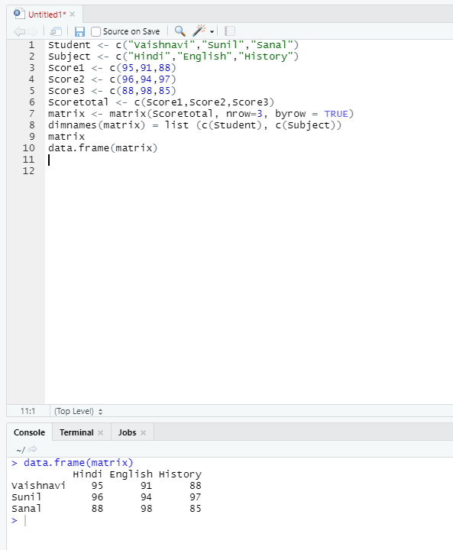

1. **Create three vectors using five countries (your choice) from the following website. The first vector should be country names, the second vector should be the total number of cases, and the third vector should contain the total number of deaths. Create a data frame using these vectors. <https://www.worldometers.info/coronavirus/>**

Ans-->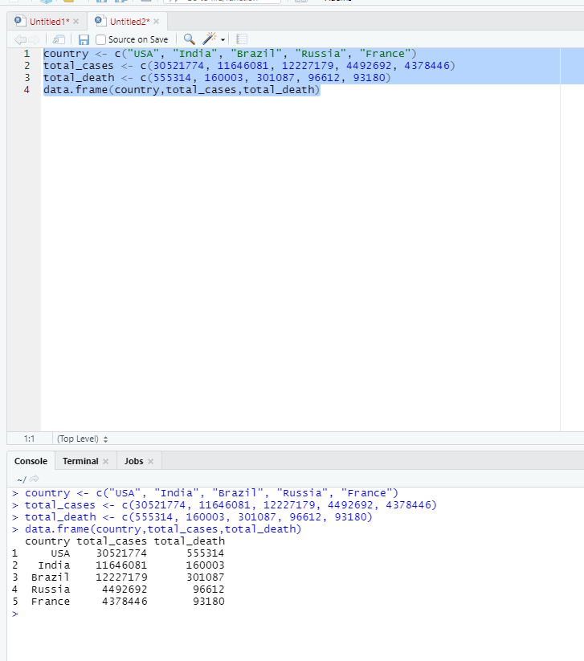

1. **Please read the mtcars data set from R. It is an built-in data set. Please check the structure of the data set. If required, please convert the data into their appropriate data types (character, logical, factor, etc). Save your results as a new data frame using a new name.**

